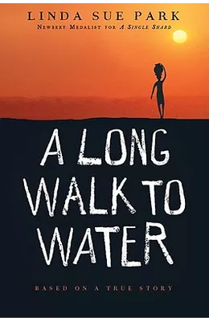

A Cross Curricular

Middle School Literature Unit

By

Julie Head, Education Director

Eastern Shore Soil and Water Conservation District

Renee Lee, Language Arts Teacher

Accomack County Public Schools

Kathleen Overman, Science Teacher

Accomack County Public Schools

cross-referenced with the Virginia Standards of Learning

**TABLE OF CONTENTS**

Information for the Teacher ……………………………………………………………………………… 3

Pre-Reading Activities for the book

Pre-Reading Assessment - Water Knowledge …………………………………………..5

Water Use Diary …………………………………………………………………………………….. 6

Anticipation Guide – version A ……………………………………………………………….. 8

Anticipation Guide – version B – scaffolded support ………………………………. 9

Chapter Activities

Chapter 1………………………………………………………………………………………………... 10

Chapter 2 ……………………………………………………………………………………………….. 13

Chapter 3 ……………………………………………………………………………………………….. 16

Chapter 4 ……………………………………………………………………………………………….. 18

Chapter 5 ……………………………………………………………………………………………….. 21

Chapter 6 ……………………………………………………………………………………………….. 23

Chapter 7 ……………………………………………………………………………………………….. 26

Chapter 8 ………………………………………………………………………………………………. 29

Chapter 9 ………………………………………………………………………………………………. 31

Chapter 10 …………………………………………………………………………………………….. 34

Chapter 11 ……………………………………………………………………………………………. 37

Chapter 12 ……………………………………………………………………………………………. 39

Chapter 13 ……………………………………………………………………………………………. 41

Chapter 14 ……………………………………………………………………………………………. 44

Chapter 15 ……………………………………………………………………………………………. 46

Chapter 16 ……………………………………………………………………………………………. 48

Chapter 17 ……………………………………………………………………………………………. 51

Chapter 18 ……………………………………………………………………………………………. 53

Post Reading Activities for the Book (includes logic skills, connections to self, and math)

Reflections on Water - Time …………………………………………………………........... 55

Reflections on Water - Distance …………………………………………………………….. 56

Reflections on Water - Weight ……………………………………………………………….. 57

Reflections on Water - Usage …………………………………………………………………. 58

Reflections on Water - Changing Our Habits ………………………………………….. 59

Appendix - Literature Arts Resources

Vocabulary Through Context - OL ………………………………………………………… 61

Character Perspective - LL ……………………………………………………………………... 62

OL …………………………………………………………………… 63

Character Changes - OL ………………………………………………………………………….. 64

LL …………………………………………………………………………. 65

Plotting the Novel - OL …………………………………………………………………………… 66

LL ………………………………………………………………………….. 67 & 68

Summary - OL ………………………………………………………………………………………... 69

LL …………………………………………………………………………………………. 70

One Pager Guide & Rubric …………………………………………………………………….. 71 & 72

Suggested SOL Writing Prompts …………………………………………………………………………. 73

Virginia English SOL Correlations ……………………………………………………………………….. 75

Works Cited ……………………………………………………………………………………………………….. 79

**Information for the Teacher**

**Description of the Story**

A Long Walk to Water is based on the true story of Salva Dut, one of some 3,800 Sudanese "Lost Boys" airlifted to the United States in the mid-1990s. Salva’s early life is abruptly disrupted by the Sudanese civil war. When the war comes to Salva’s village, he is separated from his family and is forced to survive on his own. He travels hundreds of miles on foot hoping to find his family and seeking. He survives starvation, confrontation with armed forces, animal attacks, disease, and a constantly changing political environment. Salva ultimately leads a group of about 150 boys to safety in Kenya.

After years of wondering what will happen to him, Salva finds out he is being relocated to upstate New York. Salva learns English, goes to college, and makes a life for himself in the United States. Eventually he learns that his father is still alive but seriously ill with a water borne disease. After returning to his home region to reunite with his father. Salva goes on to create a foundation that installs deep-water wells in remote villages in dire need of clean water. This poignant story of Salva's life is told side- by-side along with the story of Nya, a young girl who lives today in one of those villages.

Water for South Sudan is the foundation that was formed by Salva Dut. More information can be found at <https://www.waterforsouthsudan.org/>

60 Minutes has done several segments on the lost boys. This 12 minute video covers the boys journeys and many adjustments to the United States and may be helpful to give students an idea of the challenges they faced: <https://www.youtube.com/watch?v=6-R5YNZxj2E>

**About the Author**

Linda Sue Park is the author of many books for young readers, including the 2002 Newbery Medal winner *A Single Shard* and the New York Times bestseller *A Long Walk to Water*. Her most recent title is *Prairie Lotus*, a historical fiction middle-grade novel. When she’s not writing, speaking, teaching, or caregiving for her two grandchildren, she spends most of her time on equity/inclusion work for [We Need Diverse Books](https://diversebooks.org/) and the [Society of Children’s Books Writers and Illustrators](https://www.scbwi.org/). She is also on the advisory board of the [Rabbit hOle](https://www.rabbitholekc.org/) national children’s literature museum project.

**Using these Resources**

These resources are free for you to use. In an effort to use various resources and subjects to increase student’s environmental and social equity awareness, we hope that you will assign the ***Water Use Diary*** prior to starting the book. An important part is including the post-reading activities on ***Reflections on Water*.** These activities are designed to get kids thinking about water use and availability as well as the struggle that many people in the world face in trying to obtain safe water.

Additional information on the challenges faced by people around the globe can be found at The Water Project and Charity Water. Imagine a Day Without Water is a national education campaign that hopes to raise awareness about the disparity of access to safe water in the United States and around the world.

The science lessons were also specifically designed to accompany this novel. They cover topics and skills including data analysis, waterborne diseases, and biomes.

**Commonlit.org**

Commonlit.org is a free website that contains several paired texts to work along with the novel. Use the link to create your free account. https://www.commonlit.org/ Once you are logged in you can go to book pairings and search for *A Long Walk to Water.*

In addition, articles from the site can be translated, annotated, and read aloud for your diverse learners. Each article itself also contains other paired texts and related media that further the ideas and challenge students to compare and contrast themes, literary devices, writing styles, and topics.

We have included the suggested articles and what chapters they would correlate with. Passages are included for using after Chapter 2, Chapter 4, Chapter 6, Chapter 13, Chapter 14, and Chapter 18.

**A Long Walk to Water Pre-Assessment – Water Knowledge**

1. List all the ways you can think of that you use water.

1. You turn on the faucet and water flows out. Where does that water come from?
   1. a home well
   2. from a community well or a water treatment facility
   3. I don’t know
2. Does the water that flows out of your faucet at home have a cost?
   1. yes
   2. no
   3. I don’t know
3. Where does water go after it is flushed down the toilet or swirls down the drain in your home?
   1. to a wastewater treatment plant
   2. directly to the river, bay, or ocean
   3. through a home septic system
   4. I don’t know
4. What percentage of the average human body weight is made up of water?
   1. 50 percent
   2. 10 percent
   3. 70 percent
   4. 5 percent
5. There is more water available in some parts of the country or world because of differences in:
   1. weather
   2. climate
   3. local water consumption
   4. geography
   5. infrastructure (wells, pipes, water treatment plant, water storage tower, etc…..)
   6. all of the above
   7. none of the above
6. What are some ways that you conserve

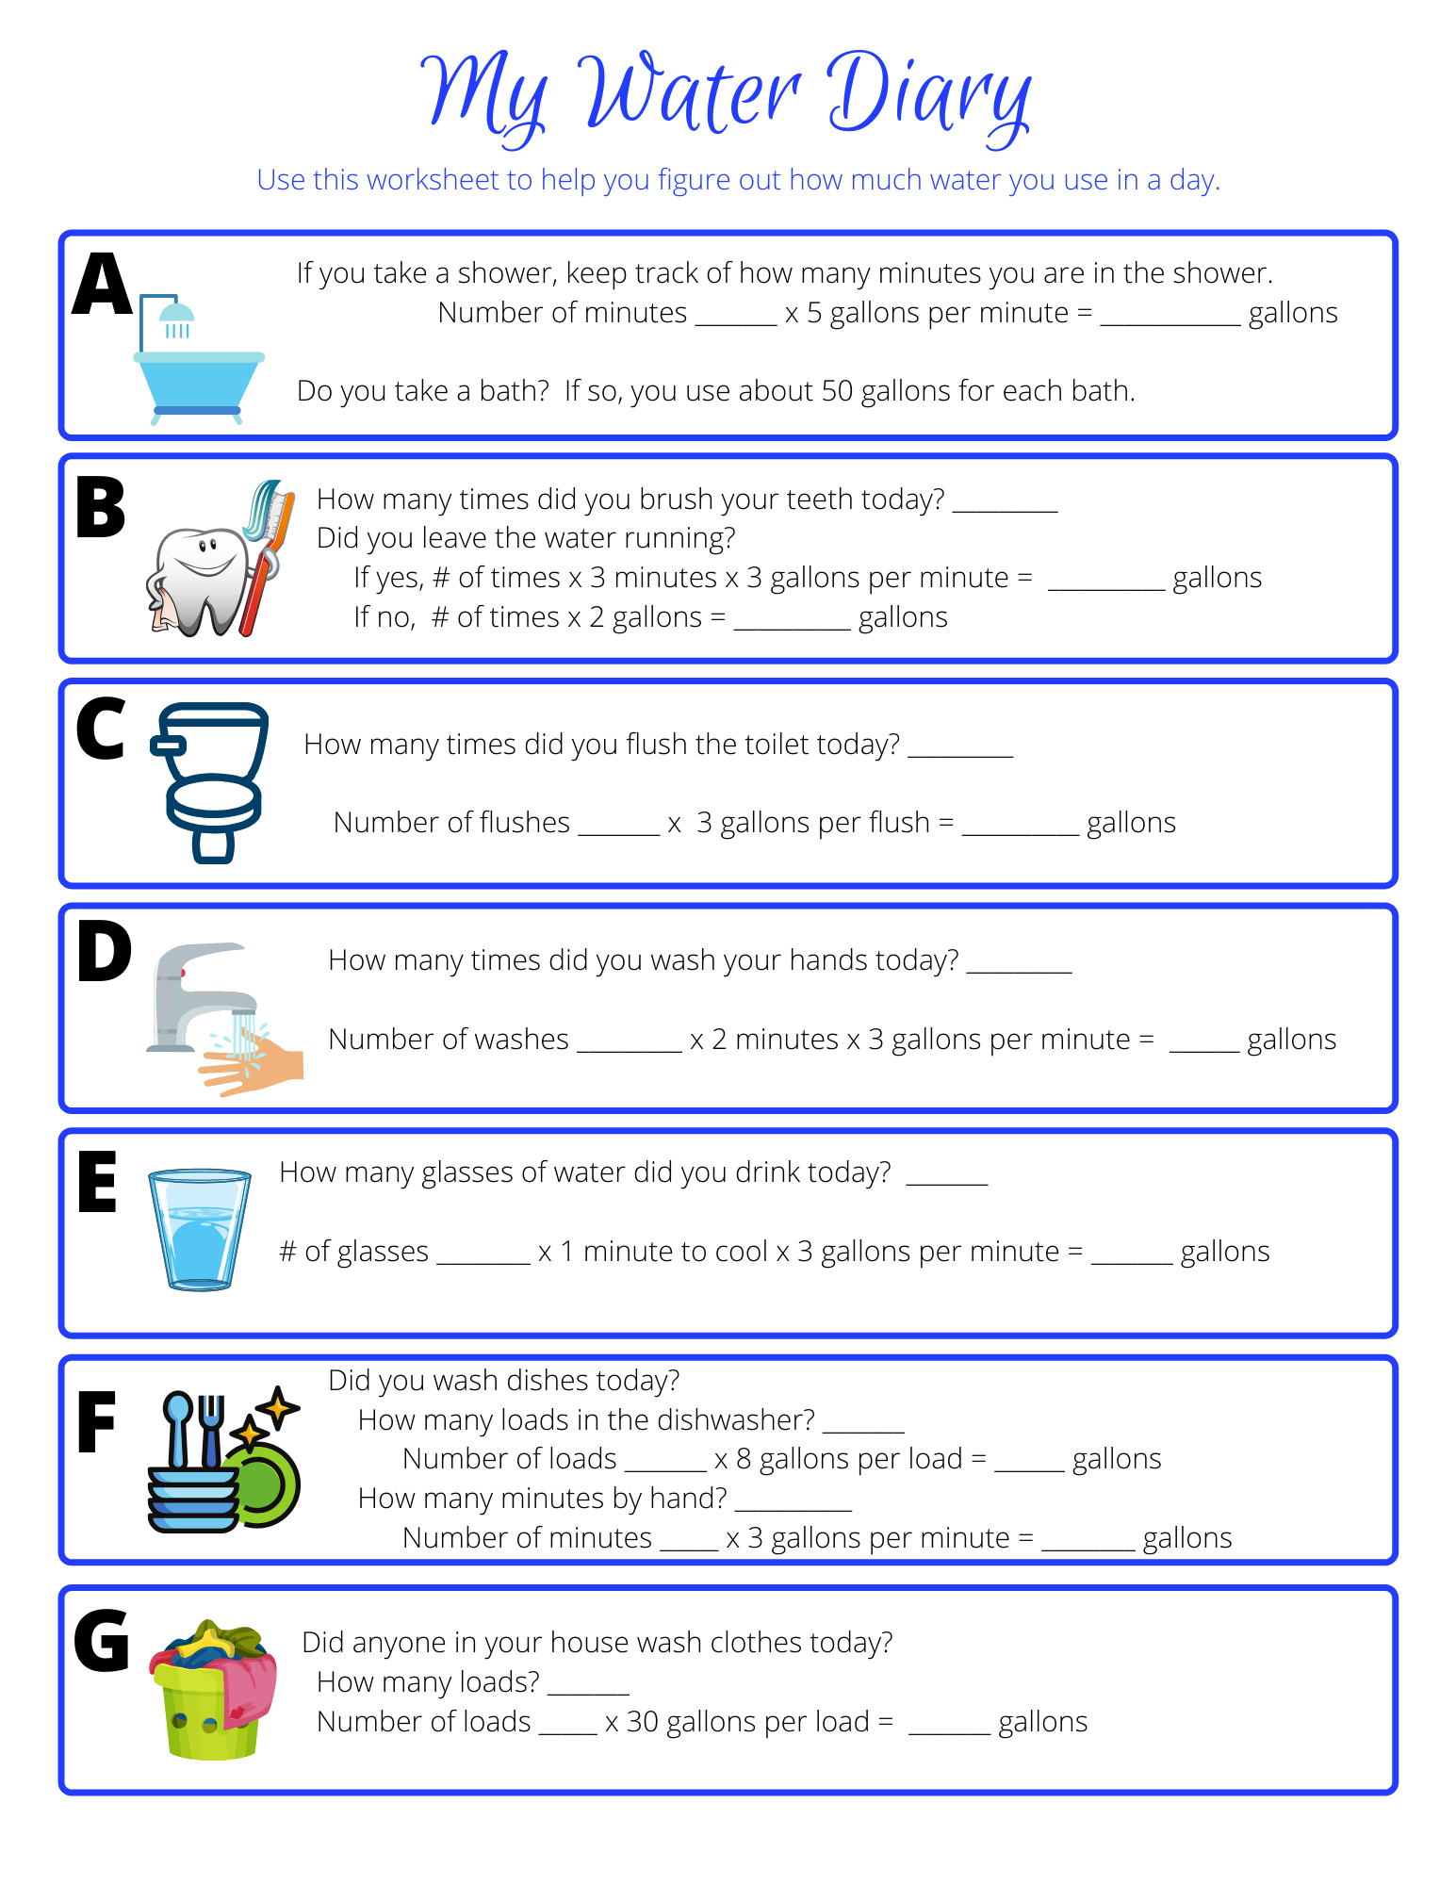

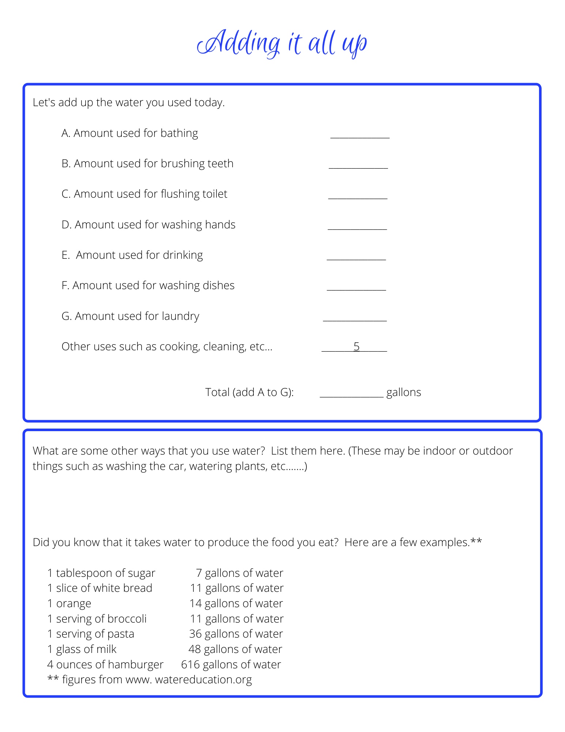

**Anticipation Guide - OL Name ____________________**

**Directions:** Read each statement. Write agree in the blank if you believe the statement and can support it. Write disagree in the blank if you do not believe the statement or you can not support it.

|  |  |  |
| --- | --- | --- |
| **Before Reading** | **Statement** | **After Reading** |
|  | Man is basically good. |  |
|  | Government should solve the problems of the people. |  |
|  | Force may be needed to get things done. |  |
|  | Government’s most important job is to protect people. |  |
|  | A leader is born, not made. |  |
|  | People will behave badly without laws. |  |
|  | Government should help people when they can’t help themselves. |  |
|  | Man must care for himself first before he can help others. |  |
|  | When a government is corrupt, people must rebel. |  |
|  | A government’s job is to make laws that people must obey. |  |
|  | War is a necessary evil. |  |
|  | The differences between right and wrong are very clear. |  |
|  | Character is born of adversity. |  |
|  | Without war there is no peace. |  |
|  | All is fair in war. |  |
|  | Water is our most precious resource. |  |
|  | Hope is our most precious resource. |  |

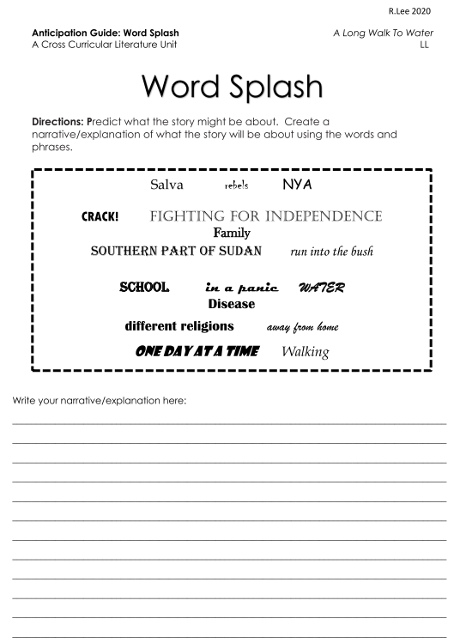**CHAPTER 1**

**Vocabulary/Definition/Content**

**thorns** “Heat, and time. And **thorns**.”

n. a sharp pointed spine on a plant or branch

**droned** “The teacher **droned** on with a lesson about the Arabic language.”

v. to talk in a dull, monotonous manor

**responsibilities** “Their **responsibilities** depended on how old they were….”

n. duties, obligations

**dress** “Others helped clean and **dress** the animal.”

v. to prepare for cooking

**panic** “Salva covered his head with his hands, but kept looking from side to side in a

**panic**.”

n. a sudden overwhelming fear

**bush** “Stay away from the villages - run into the **bush**.”

n. a large uncleared area thickly covered with mixed plant growth, trees, etc.., as a

jungle

**rebels** “He knew the **rebels** from the southern part of Sudan, where his family lived, were

fighting against the government, which was based in the north.”

n. one who opposes by force an existing government or ruling authority

**independence**  “They began fighting for **independence** from the north.”

n. freedom

**Question/Predict/Evaluate**

1. What text feature does the author use? Color, font style
2. How do these features help you understand what you are reading? These features help us see there are two different stories at different time periods.
3. Why did the author use this text feature? To separate the stories.
4. Look at the map at the beginning of the book. What do you wonder?

**2008**

1. What type of imagery is used in this sentence? “She could even drag it behind her, bumping it against the ground and raising a tiny cloud of dust with each step.” Sight
2. What type of figurative language is used in this phrase? “the sun already baking the air” personification

**1985**

1. Before his village was attacked, Salva was daydreaming about his life at home. What are three things we learn about him in this passage? Salva is a good student and likes school but can be distracted. He started school at age 10. He is learning Arabic. He only goes to school during the rainy season. He has to walk ½ hour to get to school.
2. Describe Salva’s family and home life. Salva’s father is successful. He owns many cattle and is a village judge. Salva’s father has other wives. Salva has 3 brothers and 2 sisters. Salva and his brothers take care of the cows, like to play, hunt, and make cows of clay.
3. What type of figurative language is used in the 1985 section of chapter 1.
4. What caused the rebels to fight the government? The rebels are fighting for their independence from the northern part of Sudan. The government in the north wants all of Sudan to be Muslim, the religion in the north.
5. Why does the teacher urge the students to “run into the bush.”? The teacher knows the rebels will go into the village and the boys will not be safe there.
6. What do you think will happen next in the story?

**Discussion Questions**

1. In Sudan, the rebels were at war “fighting against the government. In a democratic society, there are many ways to show disagreement with the government. What are some ways that we can disagree with our government? Discuss the pros and cons of the ways citizens can disagree with their government and elected officials.
2. What inference can you make as to why girls had to stay home and not go to school? Why did only boys go to school?

**Journal Prompts**

1. Nya seems to be going on a long walk. Where do you think she is going? Why?
2. “Salva was well aware of how lucky he was to be able to go to school.” Why do you think Salva says this? Are you lucky to be able to go to school?
3. For Salva, everything changes in an instant. Has there been a time in your life where everything changed in an instant? Explain.

**Chapter 1 Vocabulary**

|  |  |  |  |
| --- | --- | --- | --- |
| thorns | droned | responsibilities | dress |
| panic | bush | rebels | independence |

**Fill in the blank:**

1. Hooks, ____________________, and prickles are characteristic of many South African plants.
2. The conversation ___________________ on for more than twenty minutes.
3. He’s having a hard time handling his ____________________.
4. Once a hunter kills an animal, he must clean and ____________________ it or the mean will not be any good.
5. The villagers fled in ____________________ from the approaching army.
6. Pacifique Rutaganda says he slipped through a window, dodged the crowd of killers, and ran into the __________________
7. The __________________ felt that they needed to fight the government because of the unfair rules.
8. Canada was granted its ________________ in 1967.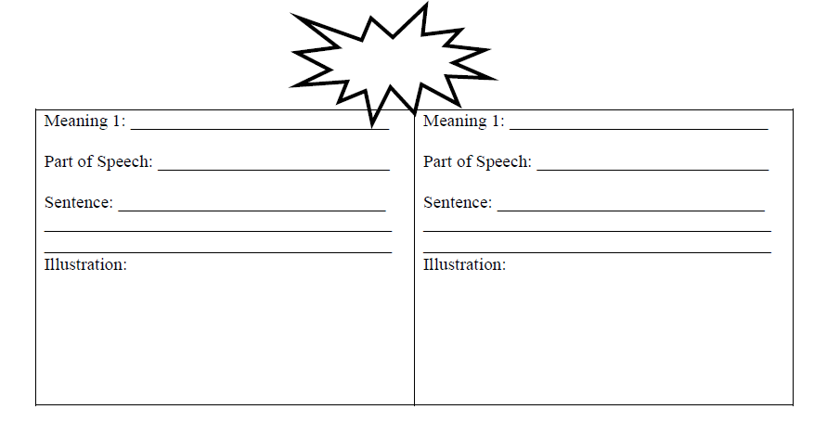

|  |  |  |  |  |  |  |  |  |  |  |  |  |  |  |  |  |  |  |  |  |  |  |  |  |  |  |  |  |  |  |  |  |  |  |  |  |  |  |  |  |  |  |  |  |  |  |  |  |  |  |  |  |  |  |  |  |  |  |  |  |  |  |  |  |  |  |  |  |  |  |  |  |  |  |  |  |  |  |  |  |  |  |  |  |  |  |
| --- | --- | --- | --- | --- | --- | --- | --- | --- | --- | --- | --- | --- | --- | --- | --- | --- | --- | --- | --- | --- | --- | --- | --- | --- | --- | --- | --- | --- | --- | --- | --- | --- | --- | --- | --- | --- | --- | --- | --- | --- | --- | --- | --- | --- | --- | --- | --- | --- | --- | --- | --- | --- | --- | --- | --- | --- | --- | --- | --- | --- | --- | --- | --- | --- | --- | --- | --- | --- | --- | --- | --- | --- | --- | --- | --- | --- | --- | --- | --- | --- | --- | --- | --- | --- | --- | --- |
| **CHAPTER 2**  **Vocabulary**  **shrouded** “He couldn’t see the school building, it was **shrouded** by smoke and dust.”  v. covered, concealed  **relief** “**Relief** flooded through him.”  n. the easing of a burden or distress, such as pain, anxiety  **model** “His father always told him to act like a man - to follow the **models** of his older brothers....”  v. example  **terror** “...this thought strengthened him enough to keep him from collapsing in **terror**.”  n. sheer fright  **mortars** “The village men were forced to carry supplies: guns and **mortars**…..”  n. a big gun that fires missiles high into the air  **Question/Predict/Evaluate**  **2008**   1. What does Nya’s experience with the thorn tell us about her? What is a personality trait you could use to describe her, based on her reaction? responsible, hard working, persevering   **1985**   1. How does Linda Sue Park describe the airplane Salva sees? like a sleek, evil bird What does this tell us about the plane? What literary device is this? 2. What is happening around Salva as he runs away from school? the school and village are being attacked 3. What three questions occupy Salva’s thoughts? Where are we going? Where is my family? Will I see them again? Can you answer Salva’s questions? 4. When the people organize by village, what does Salva discover? Salva discovers other people from his village but no one from his family. 5. How do you think Salva feels when he realizes the men with the guns are the rebels? Explain answers may vary but might include nervous, scared, safe 6. Describe the rebels. the rebels hold guns and seem fierce and watchful 7. Does Salva consider himself a man? Do the rebels consider Salva a man? Salva thinks of himself as a man but the rebels make him join the women and children. The rebel tells him he is not a man yet and not to be in such a hurry. 8. What does Salva’s choice to step forward on page 11 tell you about his character? Why? He steps forward because his father always told him to “act like a man.” He is brave. Even though he was scared he tried to make his father proud of him. 9. Reread this sentence about a rebel soldier: **“A soldier hit him the face with the butt of a gun.”** If the rebels are supposed to be the “good guys,” why are they being so harsh? answers will vary 10. Why does the group leave the rebels? the group goes in the opposite direction of the rebels because where the rebels are there is also going to be fighting 11. Why do you think they leave Salva alone in the barn the next morning? answers will vary   **Journal Prompts**   1. Nya is walking barefoot. Do you think this is because she wants to or has to? Explain. 2. Salva discovers that no one from his family is in the group. How would you feel if you couldn’t find your family? Explain. 3. How do you think Salva feels at the end of this chapter? Why? How would you feel?   **Commonlit.org**  Passage 1: Short Story: *The Last Class: The Story of the Little Alsatian*  After reading chapter 2 and following Salva’s story as he rushes from school into the wilderness at the sound of gunfire, students can discuss how Frantz and Salva are subjected to sudden change. How do both boys deal with change? What are the effects of war on everyday lives?  **Chapter 2 & Chapter 3 Vocabulary**   |  |  |  |  |  | | --- | --- | --- | --- | --- | | shrouded | relief | model | terror | mortars | | gourd | tribe | artillery | sympathy |  |   **Fill in the blank**   1. The hospital was being hit with heavy ________________ fire. 2. It was a ____________________ when her dog finally came home. 3. They glimmered faintly, like lights __________________ in fog. 4. Each ________________ occupied a recognized territory and had a common dialect. 5. The sound of guns being fired fills me with ________________. 6. She went to her best friend for ________________. 7. The little boy wears a cowboy hat because he likes to ________________ his father’s behavior. 8. Three ________________ had landed close to a group of people. 9. Pumpkins belong to the ________________ family.     **CHAPTER 3**  **Vocabulary**  **gourd** “Nya took the hollowed **gourd** that was tied to the handle of a plastic can.”  n. the hard-shelled fruit of any of various plants, whose dried shell is used for bowls and other utensils  **tribe** “He could tell by her clothing that she was not Dinka, not of his **tribe**.”  n. any group of people united by ties of descent from a common ancestor, community and traditions, adherence to the same leaders, etc….  **artillery** “During the daytime Salva could hear the distant booming of **artillery**…”  n. large caliber weapons, such as cannon, howitzers, and missile launchers, that are operated by crews  **sympathy** “She shook her head in **sympathy**.”  n. the act or power of sharing the feelings of another  **Question/Predict/Evaluate**  **2008**   1. In each of the chapters so far, the author tells Nya’s story first. Why do you think she does this? answers will vary 2. What has been the purpose of Nya’s journey every day? to get water and bring it home for her family 3. Is the water that Nya drinks clean? No, she scooped up the muddy brown water and drank it.   **1985**   1. What is Salva’s situation? Why doesn’t he return to his school? Salva is alone in a barn. He is probably scared. He probably doesn’t know exactly where he is or the way back. 2. How does the woman from the Jur-chol tribe help him? What is the history between the Nuers and the Dinka tribe? Why is Salva insulted to be called an orphan? The woman brings him food and lets him stay in the barn. The Dinka and Nuer have a long history of fighting over land and water. Because if he admits he is an orphan then he also has to admit that his family is dead. 3. How do tribes tell themselves apart from one another? by the ritual scarring on their forehead 4. What does Salva mean when he says “everything was upside down?” answers will vary but generally that nothing is the way it should be 5. Why must the old woman move on? the dry season is coming and the water hole will dry up 6. Why couldn’t she take Salva along? because the rebels won’t bother an old lady but they may bother her if she has an older boy along 7. How does Salva feel when he sees the group of people walking towards the house? hopeful, excited 8. Salva’s hopes rise and then fall. Do you think finding other dinkas will be the answer he is looking for? answers will vary   **Journal Prompts**   1. Why do you think Nya drank the muddy water? Would you drink the muddy water? Why or why not? 2. Have you ever been looking forward to something and then it didn’t happen? How did it make you feel? 3. I think the hardest part of being Salva at this point in the story would be _________________   **CHAPTER 4**  **Vocabulary**  **scanned** “Salva held his breath as he **scanned** the faces, one by one.”  v. to examine  **doubt** “Salva saw the **doubt** on the people’.s faces.”  n. uncertainty  **daze** “....today, shuffling along in a **daze**, he found he had fallen a little behind.”  n. a stunned or bewildered condition  **feast** “Honey! This night, they would **feast**!”  n. eat well or richly  **Question/Predict/Evaluate**  **2008**   1. What additional information did you learn about Nya in this chapter? that she has a younger brother and sister, for seven months out of every year she spends all day walking to get water for her family.   **1985**   1. Why doesn’t the group want Salva along? they say he is just a child and he will slow them down 2. Why is he ultimately taken along by the man and woman? because he is Dinka 3. What does it mean they are “walking to nowhere”? they don’t really have a destination, they are just trying to avoid the fighting 4. How do they survive? sometimes they find a few fruits 5. Why do the boys, Buksa and Salva, fall behind? they are hungry and tired 6. What have they discovered? a beehive 7. Can an entire group of people exist on this? no but it will give them some food for right now   **Discussion/Extension**  In today’s news media there are many stories competing for the reader’s attention. How does the news media use text, color, pictures, and other visuals to attract the reader? As a class or in small groups have students scan through current news media and decide what are the three most important stories that everyone should know about and read. Have students pick one and write about why they think that is the most important story and how they came to that decision.  **Journal Prompts**   1. Describe a typical day in Nya’s life. How does this compare to a typical day in your life? 2. Describe a typical day in Salva’s new life. How does this compare to a typical day in your life   **Commonlit.org**  Passage 2: Folktale: *The Story of the Lazy Boy: A Kachari Folktale*  After reading chapter 4 when the old lady allows Salva to sleep in her barn, students can compare and contrast Salva with the Lazy Boy. How is Salva’s attitude different after he sleeps in the barn to the Lazy Boy’s attitude? How does Slav’s hard work affect the way the old lady treats him? How does the young boy from the folktale suffer for being lazy? What lessons can be learned from the novel and the folktale?  Passage 3: Poem: *Learning to Read*  After reading chapter 4 learning that it is Nya’s job to carry the water back and forth and Salva considering himself lucky to go to school, have students discuss the idea of how girls are not able to go to school. Have students discuss the value that the speaker in Harper’s poem places on learning to read. How would Harper feel about Nya and Salva’s sisters not being allowed to go to school? Do you feel that it is either fair or unfair that the girls in the book don’t go to school?  **Chapter 4 and Chapter 5 Vocabulary**   |  |  |  |  |  | | --- | --- | --- | --- | --- | | scanned | doubt | daze | feast | gingerly | | honeycomb | accent | strides | inhabited |  |   **Fill in the blank**   1. He crossed the room in two ________________. 2. Villagers used to hold a great _______________ at harvest time. 3. She anxiously ________________ the faces of the men leaving the train. 4. The woods are ________________ by many wild animals. 5. ________________ she reached out to touch the cat. 6. He speaks with a strong southern ________________. 7. She wandered around in a ________________, not quite sure what to do. 8. ________________ is very sweet. 9. There is some ________________ about the best way to do it.   **Multiple Meaning Words**  **CHAPTER 5**  **Vocabulary**  **gingerly** “It was worth it, Salva thought, as he touched his eye **gingerly**.”  adv. with great care or caution  **honeycomb** “Nothing had ever tasted so good as those pieces of **honeycomb** dripping with rich luscious gold sweetness.”  n. a structure of hexagonal cells of wax, made by bees to store honey and eggs  **accent** “The boy spoke Dinka but with a different **accent**, which meant that he was not from the area around Salva’s village.”  n. a distinctive mode of pronunciation of a language, especially one associated with a particular nation, locality, or social class.  **strides** “When they walked side by side, their **strides** were exactly the same length.”  n. a long step in walking  **inhabited** “Their region was **inhabited** by large herds of antelope, wildebeest, gnus..”  v. occupied, to live in  **Question/Predict/Evaluate**  **2008**   1. Explain how water dictates Nya’s life. her whole life is spent collecting water 2. If the lake has more water than the pond, why can’t Nya’s family just stay there year-round? there is too much fighting between the Nuer and the Dinka over the land around the lake 3. How is Nya’s water collection different at the lake camp? instead of walking all day Nya has to wait all day for the hole to fill with water   **1985**   1. How was the honey worth it for Salva and the others in his group? they all had full stomachs 2. What was the cost of getting the honey? some of them got stung 3. How does Salva know that Marial was not from his village? he speaks with a different accent 4. What do Salva and Marial have in common? neither boy has been able to find any family members, they are the same age and the same height 5. What does it mean that Salva “heard that sigh all the way to his heart?” answers may vary but something along the lines of he understands what Marial is feeling 6. Why is Salva dismayed that they are walking to Ethiopia, east? he worries that if they walk to a different country he will never find his family 7. How are the boys good for each other? answers will vary 8. Describe the Atuot people. Would you fear them? they are described as the people of the lion. When they die they come back as lions who want human flesh. 9. How much time has passed since Salva started running? more than one month   **Extension**  Have several story starter prompts and have students write their own stories.  **Journal Prompts**   1. This morning I woke up and there was no water in my house. This is how my day went……. 2. Salva is amazed at the end of this chapter. Why do you think he is speechless?   **CHAPTER 6**  **Vocabulary**  **makeshift** “They had no house and had to sleep in **makeshift** shelters.”  adj. done or made using whatever is available, temporary  **solemn** “His face became very **solemn** when Salva told him that he had not seen nor heard a single word of his family in all that time.”  adj. serious  **rebelled** “After so many weeks of near-starvation, his stomach **rebelled** mightily….”  v. to reject or fight against  **nausea** “At one point Salva found himself in a line of half a dozen people, all in an identical pose - bent over, holding their stomachs, and waiting for the next wave of **nausea**.”  n. stomach sickness  **exhausted** “For ten hours they walked, and near dawn the next morning, everyone was **exhausted**.”  adj. completely worn out  **wailing** “As he opened his eyes, he hear**d wailing**.”  n. a long, loud, high-pitched cry, as of grief or pain  **Question/Predict/Evaluate**  **2008**   1. Nya and her mother think differently about the camp. Explain. Nya likes it because she doesn’t have to make the two long trips for water each day. Her mother does not like it because they don’t have a real house, they don’t have most of their things, and she is scared that her husband and son will be killed by the Dinka while they are out hunting. 2. Would Nya and Salva have been friends if they knew each other in the same time? Explain. Not likely because they are from different tribes.   **1985**   1. Finally, something good happens for Salva. Explain. How does this make a difference for the group? Salva discovers that his uncle is in the group. His uncle has a gun so they can hunt for food. 2. Why does everyone in the group become nauseous? Could they have avoided this problem? They have been starving for weeks and ate too much when the meat was available. If they had eaten a little bit and waited awhile before eating again their bodies might have handled it better. 3. List all the elements working against their survival. Lack of water, lack of food, lack of shelter, exhaustion, wild animals……. 4. What does it mean: “A cold fist seemed to grip Salva’s heart.”? What has happened? His uncle saying he is sorry means that something bad has happened. We don’t know what has happened yet but Salva looks around for Marial and doesn’t see him.   **Journal Prompts**   1. If you had to choose to be Nya or Salva, whose shoes would you rather walk in? Explain your choice. 2. Have you ever experienced a time when you felt something bad had happened but you didn’t know why? How did that make you feel? 3. Imagine that you had to sleep outside with no protection. How would that make you feel? Explain.   **Commonlit.org**  Passage 4: Informational Text: *Strength in Numbers*  After reading chapter 6 when Salva meets Marial, is reunited with Uncle Jewiir, the group gets bigger, students can discuss the human tendency to group themselves together. How do Salva and the group of people he is walking with rely on each other? How does Salva directly benefit from being in the group? How would you use the BirdBrain Science text to classify both Salva and Nya? How might Nya’s family rely on numbers once they begin to camp at the lake?  **Chapter 6 Vocabulary**   |  |  |  | | --- | --- | --- | | makeshift | solemn | rebelled | | nausea | exhausted | wailing |   **Fill in the blank**   1. My poor sick stomach ________________ at the idea of any more food. 2. The refugees had been living in ________________ tents for a year. 3. The long journey ________________ the children. 4. He looked very ________________ when he announced the news. 5. The cat was ________________ to be let out. 6. The workers had complained of headaches and ________________.   **Multiple Meaning Words**    **CHAPTER 7**  **Vocabulary**  **steady** “Uncle spoke to him all morning in a steady, low voice.”  adj. firm, even, regular  **reeds** “Salva staggered forward with another load of reeds in his arms.”  n. the stalks of various tall perennial grasses  **papyrus** “Some people were cutting down the tall papyrus grass by the water’s edge.”  n. a tall, aquatic plant native to the Nile valley  **prow** “Salva watched, fascinated, as little by little the curve of a prow and low sides grew from the piles of reeds.”  n. the bow or front part of a boat  **Question/Predict/Evaluate**  **2008**   1. What is wrong with Akeer? What are her symptoms? Akeer is sick. She had stomach pains and now she has diarrhea. 2. What is the choice facing the family? What would you do? The clinic is a walk of several days and Akeer is already very weak. Should they stay there or should they make the long journey and get medical treatment.   **1985**   1. How do they know a lion took Marial? They are in lion country and they know that Marial would not have wandered away from the group. There was nothing left except for a few spots of blood. 2. How is it possible that no one heard anything? It was dark and the wind was rippling the tall grass. Lions are very stealthy and sometimes go after small, motionless prey. 3. How does the loss of his friend affect Salva? It makes him very afraid of also being taken by a lion 4. How does uncle soothe him? He spoke to him a low, steady voice and reassured him that he had a gun and would shoot any lion that approached. 5. What changes as the group approaches the Nile? The landscape became more green and the air smelled of water 6. How do they get across? they build boats/canoes out of the papyrus grass 7. What is the secret of making the canoes? the reeds had to be tied together and woven tightly 8. What would you like to learn in the next chapter?   **Journal Prompts**   1. Sometimes people will say they were paralyzed with fear. What does this mean? Have you ever been paralyzed with fear? 2. Have you ever lost a friend? Maybe they moved away or you got in a fight. How did you feel?   **Chapter 7 and Chapter 8 Vocabulary**   |  |  |  |  |  | | --- | --- | --- | --- | --- | | steady | reeds | papyrus | prow | monotonous | | gauge | mangoes | ferried | desperate |  |   **Fill in the blank**   1. We could see the moon over the ________________ swamps. 2. Water had to be ________________ from the nearest hydrant using a bucket. 3. It was difficult to ________________ whether he was angry or not. 4. The drummer beat out a ________________ rhythm while we marched. 5. They are in ________________ need of food and shelter. 6. Tropical fruit such as ________________ and kiwis can be used to make a fruit salad. 7. He stands on the ________________ looking at the sea. 8. A movement in the ________________ caught my eye. 9. The music became ________________ after a while.   **Multiple Meaning Words**    **CHAPTER 8**  **Vocabulary**  **monotonous** “The scenery and motion were so **monotonous** that Salva might have slept….”  adj. boring, repetitive  **gauge** “He kept himself awake by counting the strokes of Uncle’s paddle and trying to **gauge** how far the canoe traveled with every twenty strokes.”  v. to measure  **mangoes** “As a special treat, his father sometimes bought **mangoes**.”  n. an oblong, sweet fruit of a tropical tree that is green on the outside and orange on the inside  **ferried** “So Salva’s father **ferried** the mangoes home by wedging them into the spokes of his bicycle wheel.”  v. transported, carried  **desperate** “...Salva slapped and waved at them in **desperate** frustration all night long.”  adj. extreme  **Question/Predict/Evaluate**  **2008**   1. After Akeer was treated at the hospital, the nurse told Nya’s mother how to prevent illness in the future. Why did this worry their mother? The nurse tells them that they need to boil the water to a count of 200 and then let it cool before they drink it. The mom is worried because there is not enough water to boil it that long and still have some water in the pot. It is not realistic that Akeer will always be able to drink boiled water. 2. Explain how Akeer’s laugh “was like music.” Nya was happy that Akeer was feeling better so Akeer laughing made everyone feel good.   **1985**   1. What wonders were found on the island? Lots of food. Fish, hippo, crocodile, sugar cane, cassava, and yams 2. How do the villagers get food without any money? they have to beg for it 3. What do the mangoes symbolize for Salva? family, food, life before the fighting when it was better, happier times 4. What does the color orange symbolize? his mom because she had an orange headscarf 5. Why don’t they become nauseous again with this food? Salva sucks on a piece of sugar cane and then he eats his food very slowly 6. Describe Salva’s good memories. his dad coming home from the market, his mom cutting up mango for him 7. Why do all the fishermen disappear so quickly at sunset? they know that the mosquitos are going to come out 8. As Salva and his group made the final trip from the island to the other side of the Nile, what do the fishermen advise the group to do? Why? the fishermen tell them to take as much water as they can because there is desert on the other side and not much water. 9. Of all the elements Salva has faced, which do you think is the worst? How could the Akobo Desert that lies ahead be the worst?   **Journal Prompts**   1. If I could have anything I wanted to eat it would be…….? Why? 2. Describe your favorite memory. What makes it special?   **CHAPTER 9**  **Vocabulary**  “The sun was **relentless** and **eternal**: there was neither wisp of cloud nor whiff of breeze for **relief**.”  **relentless** adj. severe, harse  **eternal**  adj. neverending  **relief** n. the easing of a burden or distress, such as pain, anxiety, or oppression  **arid** “Each minute of walking in that **arid** heat felt like an hour.”  adj. without moisture  **parched** “His lips became cracked and **parched**.”  adj. dried out by heat or excessive exposure to sunlight  **sobs** “Salva lifted his head, the **sobs** interrupted by surprise.”  n. loud weeping  **tamarind** “He took out a **tamarind** and handed it to Salva.”  n. the fruit of a tropical Asian evergreen tree  **Question/Predict/Evaluate**  **2008**   1. Describe the visitors to Nya’s village. They probably seemed rich to the villagers because they came in a jeep 2. How does the village chief welcome strangers? They sit in the shade and drink tea and talk 3. What do you think they want? they are asking about water   **1985**   1. How is the Akobo the worst element yet for the villagers to survive? it is hot, there is no shade or water, there is no breeze to cool them, some of them have no shoes 2. How did Salva stubbing his toe almost lead to a very different outcome for him? He started to lag behind the group. If it hadn’t been for his uncle he probably would have been left in the desert to die. 3. How does uncle encourage Salva to keep walking? He uses his full name and tells him he just needs to walk to the next acacia tree, pile of rocks, etc….. 4. What might have happened to Salva without his uncle? He might have died 5. What do they find when they reach other people in the desert? that they are dying because they don’t have any water 6. What is the choice the group faces with the men? should they give water to the men 7. What will happen if they don’t give water to the men? they will probably die 8. What will happen if they do give water to the men? it may ease the suffering of the men but they may not have enough water for themselves   **Journal Prompts**   1. How could you apply uncle’s strategy in your own life? 2. Would you give water to the men? What do you think the right thing to do is? Why?   **Teaching Suggestions:**  Beginning in Chapter 9 and through to Chapter 17, the major topic of the novel becomes evident. Salva’s Uncle shows Salva how not to give up, be determined, and have perseverance. Salva continues with this idea every time he has an obstacle. He says he will take it one moment at a time, one day at a time, or one problem at a time to get through whatever obstacles are upon him. Additionally, Nya also shows determination and perseverance as she has to walk to get water for her family daily in order to survive. During these chapters, you can begin the discussion of how a topic can become a theme. Students can create theme statements.  Some example topics:  Not giving up  Determination  Perseverance  Courage  Family  Independence  Surviving/Survival  Some example themes:  Independence is necessary to grow up, even though it can be scary.  With hard work and determination you can achieve your goal/dream.  It is important to never give up.  Do what you must to survive.  Family is important.  Families face adversity together.  Value your family.  One can overcome difficult obstacles and survive.  **Chapter 9 Vocabulary**   |  |  |  |  | | --- | --- | --- | --- | | relentless | eternal | relief | arid | | parched | sobs | tamarind |  |   **Fill in the blank**   1. The child’s body was shaking with ________________. 2. Will you two never stop your ________________ arguing! 3. Nothing grows in these ________________ conditions. 4. She could not bear the ________________ music and turned down the volume. 5. Look at that ________________ tree with those two green parrots. 6. He raised the water bottle to his ________________ lips. 7. We all breathed a sigh of ________________ when he left.   **Making Your Own Sentences -** Pick two words and write your own sentences using those words.   |  | | --- | |  | |  |   **CHAPTER 10**  **Vocabulary**  **translated** “The friend answered in the same language, but as he walked back toward the group, he **translated** it for the chief…..”  v. to turn from one language into another or from a foreign language into one’s own  **revived** “Like a miracle, the small amounts of water **revived** them.”  v. to restore to life  **vultures** “**Vultures** would find the bodies and strip them of their rotting flesh until only the bones remained.”  n. any of various large birds of prey  **corpses** “He felt sick at the thought of those men - first dying in such a horrible way, and then having even their **corpses** ravaged.”  n. dead bodies  **refugee camp** “By the end of the day, they would be out of the desert, and after that, it would not be far to the Itang **refugee camp** in Ethiopia.”  n. shelter for persons displaced by war or political oppression or for religious beliefs  **Question/Predict/Evaluate**  **2008**   1. Why is Nya so confused about the visitors? The men say there is water halfway between the two trees but Nya knows there is not. She doesn’t realize they are talking about digging a well.   **1985**   1. Did Salva give his water to the men? Did anyone? What were the results? Salva’s uncle told him to save his water because he would need it. Some of the women gave the men water. The men recovered enough to start walking with the group. 2. What happened to the village of Lou Arik? they think it was attacked and burned and that most of the people were killed 3. What will happen when the group reaches Ethiopia? they will go to the refugee camp 4. What are uncle’s plans? Uncle is going to return to Sudan and fight in the war. 5. What are the chances that Salva will ever find his family? Not very good. 6. Who were the men who approached Salva’s group? They are from the Nuer tribe. 7. How does Salva know who they are? By the ritual scarring on their faces. 8. Why did the six men single out uncle? Probably because he has the gun 9. What does it mean, “There was something evil in their laughter.”? Student discussion. 10. What was the last thing the men did before running away? They kill Uncle. 11. Why would these men attack fellow southerners? They are from a different tribe and probably more like thugs than like soldiers. 12. What does the ending of this chapter mean for Salva? He has no family left that he knows of.   **Journal Prompts**   1. Would you give what little water you had to the men? Why? 2. What role should the United States play in the refugee problems around the world? Should refugees from other countries be our concern? 3. Do you think the men would have killed Uncle if he hadn’t had a gun? Why or why not?   **Chapter 10 and Chapter 11 Vocabulary**   |  |  |  |  |  | | --- | --- | --- | --- | --- | | translated | revived | vultures | corpses | refugee camp | | scythed | mourn | numbness | grudgingly | emaciated |   **Fill in the blank**   1. The ________________ were already circling around the dead animal. 2. She ________________ admitted that I was right. 3. He ________________ the speech from French into English. 4. He was still in a state of ________________ and shock from the accident. 5. Her fur was matted and she was so ________________ she could hardly stand. 6. He ________________ after a rest and some food. 7. Today, we ________________ for all those who died in two world wars. 8. The first truckloads of food arrived at the ________________ today. 9. The ground was littered with the ________________ of enemy soldiers. 10. The girl inhaled the scent of newly ________________ grass.   **Making Your Own Sentences -** Pick two words and write your own sentences using those words.   |  | | --- | |  | |  |   **CHAPTER 11**  **Vocabulary**  **scythed** “The long grass had to be **scythed** and hoed under.”  v. cut down  **mourn** “Out of respect for him, the group walked no more that day, but took time to **mourn** the man who had been their leader.”  v. to feel or express sorrow or grief  **numbness** “Despite the **numbness** in his heart, Salva was amazed to find himself walking faster and more boldly than he had before.”  n. loss of feeling  **grudgingly** “It seemed that they had all forgotten that, for Salva now had to beg for scraps, which were given **grudgingly**.”  adv. reluctantly, unwillingly  **emaciated** “It did not seem as if the camp could possibly hold any more, but still they kept coming: long lines of people, some **emaciated**.”  adj. to become extremely thin, especially as a result of starvation  **Question/Predict/Evaluate**  **2008**   1. Based on the information so far, make a prediction about what the visitors to Nya’s village might be doing. digging for water, drilling a well 2. What will it mean if water is found in the land between the trees? Safe, clean water to drink. The women and girls will not have to spend all day walking for water.   **1985**   1. How does Uncle’s death affect Salva? He was numb. He was annoyed that they wouldn’t be able to eat. 2. What keeps Salva moving forward, even as he grieves Marial’s and uncle’s deaths? He knows that Uncle and Marial would want him to keep going and make it to the refugee camp? 3. How does the group’s attitude change toward Salva? They start grumbling that he is too small and will slow them down. They won’t give him anything to eat or drink. 4. What are some observations Salva makes when he arrives at the Itang refugee camp? There are so many people, people are everywhere, there isn’t a lot of room so if people lay down they can’t stretch their legs out, most of the refugees were boys and young men who had fled the fighting…….. 5. What are the positive and negative aspects of the refugee camp? Positive - There is food to eat and they are safe from the war. Negative - There are already so many people there but there are long lines of more people coming and how will they all fit? 6. Is Salva happy to finally quit walking? After walking for so long he finds it strange to stay in one place. 7. Look back at the map of Salva’s route. Where is Itang? It is in Ethiopia and is near the Gilo River 8. When he arrives at Itang, Salves sees “orange....an orange headscarf,” and starts following it. What does the orange scarf mean to Salva? What can you infer about what Salva is thinking? Orange is a color worn by the Dinka. His mom had an orange headscarf. He is hoping it is his mother and maybe some other members of his family. 9. What does the color orange symbolize?(refer to Chapter 8) The color orange symbolizes his home and family. In addition to his mother having an orange headscarf, his dad would bring home mangoes from the market which are orange on the inside.   **Journal Prompts**   1. If you place an ad in the news media you are charged by the word. The longer your ad, the more it costs. Write a one sentence summary of this chapter using as many vocabulary words as you can. Imagine you are paying $0.10 per word and you only have $2.00 to work with for each chapter. See if you can sum up the chapter in twenty words. If you use a vocabulary word from the chapter in your summary that word is free. 2. What is something that symbolizes home and family to you? Is it a thing, a color, a scent……? Why does this symbolize home and family for you?   **CHAPTER 12**  **Vocabulary**  **despair** “He felt as though he were standing on the edge of a giant hole - a hole filled with the black **despair** of nothingness.”  n. hopelessness  **scavenging** “Some preferred to spend their time **scavenging** for food, or items that could be traded for food.”  v. to search for and collect anything useable from discarded waste  **chaos** “The **chaos** was immediate.”  n. a state of utter confusion and disorder  **surge** “Salva was caught up in the **surge** at once.”  n. a strong, wavelike, forward movement or rush  **merciless** “Swollen by the rains, the Gilo’s current would be **merciless**.”  adj. cruel, pitiless  **Question/Predict/Evaluate**  **2008**   1. What is the “red giraffe”? a very tall drill 2. Why might Nya describe it this way? drill kind of look like they have a long neck with a head on top 3. What are the villagers doing and how do they feel about this work? Some are carrying rocks from the pond and others are breaking them up into gravel. Nya doesn’t know why they are doing this.   **1985**   1. What does the “orange scarf” woman force Salva to admit to himself? That his family is truly gone. They have likely died from bullets, bombs, starvation, or sickness. 2. How does it feel to Salva to be without a family? he feels alone 3. What has he lost? Answers will vary but he has pretty much lost everything. 4. How does he continue to go on, despite the “black despair of nothingness” he is feeling? He knows that his family would have wanted him to go on and to make something of their memories. 5. What does Salva decide to do to survive? He does what his uncle did for him in the desert. He only has to get through this one day. Kind of like our take one day at a time cliche.   **1991**   1. How long did Salva stay in Itang? 6 years 2. Why is the camp closing? Foreign aid groups run the camps but the Ethiopian government gives them permission to be there. The Ethiopian government is collapsing. 3. Why does Salva leave? The refugees are forced out at gunpoint. 4. What will be the outcome of the government’s action of closing the camp? There were once again thousands of people with no place to go.   **Journal Prompts**   1. Do you think the villagers actually believe that there will be water between the trees where it is dusty and dry? Why or why not? 2. Of all the difficulties Salva has faced so far, which one do you think would be the worst? Explain.   **CHAPTER 13**  **Vocabulary**  **earnestly** “If that didn’t work, he would talk to them **earnestly** and try to persuade them.”  adv. in a serious manner  **prodding** “The soldiers were forcing some of them into the water, **prodding** them with their rifle butts.”  v. to poke or jab at someone or something  **stunned** “**Stunned**, Salva realized that being forced under the water had probably saved his life.”  v. shocked  **welter** “The rain, the mad current, the bullets, the crocodiles, the **welter** of arms and legs, the screams, the blood….He had to get out somehow.”  n. a confusing mass, a jumble  **peril** “Every group had stories of terrible **peril**.”  n. danger  **Question/Predict/Evaluate**  **2008**   1. What things make this drilling so difficult? You have to have water for the drill to work so the men had to get water from the pond in a big bag. They bag kept springing leaks 2. How did “the boss” handle the drilling crew when the bag kept springing leaks? What character trait or traits does this show? He would encourage the workers by laughing and joking with them. If that didn’t work he would speak to them earnestly. Finally he would get mad. Answers will vary as to what character traits this shows.   **1991-1992**   1. What is the government trying to do by driving the people into the water? Make them leave Ethiopia, kill them 2. Why are the soldiers shooting? They want everyone out of Ethiopia and they don’t care if they are alive or dead. 3. What are all the obstacles to survival for the people that the government forces into the river? It is raining so the current is very strong and they may drown. A crocodile may attack them and kill them. They may get shot by soldiers and killed or wounded. If they survive those things they still have nowhere to go. 4. Why was Salva one of the lucky ones and not one of the thousands who died? The boy who clung to him protected him for being the one who was shot. 5. Where is Salva headed next? He knows he can’t go to Sudan because they are still fighting and he can’t go back to Ethiopia because he will be shot by the soldiers. He has heard there are refugee camps in Kenya so he decides to go to Kenya. 6. Look back at the map. What will he face on this part of the journey? He will have to travel back through part of Sudan where there is fighting. The terrain is mostly desert. 7. How does Salva’s role change when he joins up with the next group? He becomes a leader of the group. 8. Why did he become a leader? Probably because by this time he was one of the older boys. 9. What do the boys hope to find in Kenya? Safety, another refugee camp. 10. How do they organize? Everyone was given a job, even the smallest. They might scavenge for food, collect firewood, stand guard while they slept, etc….. When the youngest are too tired or weak to walk the older boys take turns carrying them. 11. How do the boys find the strength to go on for a year and a half before they get to Kenya? One step at a time, one day at a time. Just today to get through. 12. What do you expect their life to be like in Kenya? answers will vary but maybe a lot like it was at the refugee camp in Ethiopia   **Journal Prompts**   1. Have you ever been in a situation where nothing seems to go right? Describe the situation and what you did to keep going. 2. Would you follow Salva? Why or why not?   **Commonlit.org**  Passage 5: Informational Text: *Stress for Success*  After reading chapter 13 when Salva has led the other boys on the long journey from Ethiopia to Kenya, students can use the scientific research to study Salva’s character. How does Salva reduce a mountain into a molehill? Do you believe that Salva would have felt any of the things that Steven’s talks about in her article? How has Salva coped with stressful situations in the novel so far?  **Chapter 12 and Chapter 13 Vocabulary**   |  |  |  |  |  | | --- | --- | --- | --- | --- | | earnestly | prodding | stunned | welter | peril | | despair | scavenging | chaos | surge | merciless |   **Fill in the blank.**   1. A low moan of ________________ escaped her as she realized what had gone wrong. 2. The refugees were in ________________ peril of death from hunger. 3. They walked around him, ________________ and pinching him. 4. She ________________ appealed to her friends for support. 5. The breeze brought some relief from the ________________ summer heat. 6. A serious road accident caused traffic ________________ yesterday. 7. There is a ________________ of information on the subject. 8. Her words ________________ me - I had no idea she felt that way. 9. A ________________ of people poured through the gates. 10. The flood has left villagers and animals desperately ________________ for food.   **Multiple Meaning Words**    **CHAPTER 14**  **Vocabulary**  **misery** “After two years of **misery** at Kakuma, Salva left the camp.”  n. great suffering  **ration** “There was nothing to do but wait - wait for the next **ration** of food.”  n. a fixed amount  **rumor** “A **rumor** was spreading throughout the camp.”  n. gossip, hearsay  **administration** “One day a notice was posted at the camp’s **administration** tent.”  n. the management of an office, business, or organization  **Question/Predict/Evaluate**  **2009**   1. Why does the village celebrate? Because water starts coming out of the borehole. 2. Why isn’t Nya happy when the borehole water starts flowing? Because she realizes the water is brown and full of mud so it is still dirty water. 3. What could it mean that the new water is full of mud? Answers will vary.   **1992-1997**   1. How much time has now passed since Salva fled from his school? 11 years. He was 11 when he fled into the bush and he is now 22. 2. Describe the misery at Kakuma. It was an isolated, dry, windy place with tall fences made of barbed wire. You weren’t allowed to leave unless you weren’t coming back. The local people would sometimes steal from the refuges. 3. How does the population of Kakuma compare to the population in your own community? Answers will vary but there were 70,000 people at Kakuma 4. How were the conditions at the camp in Ifo different from the Kakuma camp? They weren’t, everyone was always hungry as there wasn’t enough food. There wasn’t enough medical care and there was nothing to do 5. What must it have been like with nothing to do day after day but wait? Boring, hopeless….. 6. What does Salva mean when he thinks, “it was hard to keep hope alive when there was so little to feed it?” He had nothing to look forward to and there seemed to be no hope that anything would ever be different. 7. Ideally what does Salva want? First he wants to learn to read English. When they start taking boys to America he want s to be one of them. 8. What are the restrictions to a boy “getting on the list” to go to America? They had to be healthy, never have been a soldier, and they had to be orphans. 9. What does the author mean “sometimes he felt he was being torn in two by the hoping and the not-hoping?” Answers will vary. He wants to have hope that he will get to go to America but he doesn’t want to get his hopes up only to get them crushed. 10. What does it mean to Salva that he will go to America? A new start, hope.   **Journal Prompts**   1. How would you feel about the water if you were in Nya’s shoes? Explain. 2. In the process of being chosen to go to America, the second step for Salva was an interview. Write up the questions you think would be important to ask a refugee in order to decide if they should leave their country and be able to enter another. How might Salva have answered each question? 3. If you were Salva, would you want to leave everything you know behind and go to America? Why or why not?     **Commonlit.org**  Passage 6: Nonfiction: *Diary of a Teenage Refugee*  As students come close to completing chapter 14 and read how Salva spends his time in the refugee camps in both Ethiopia and Kenya, use this text to provide insight for students into the life at a refugee camp. What are the similarities between Salva and Amira’s living conditions? How do Salva and Amira pass the time while they are living in the camps? How would you feel living in a camp?  **CHAPTER 15**  **Vocabulary**  **siblings** “Salva would have **siblings**, just as he had before.”  n. brothers and sisters  **terminal** “The glass doors of the airport **termina**l slid open.”  n. a [building](https://dictionary.cambridge.org/dictionary/english/building) in an [airport](https://dictionary.cambridge.org/dictionary/english/airport) or in a [place](https://dictionary.cambridge.org/dictionary/english/place) near an [airport](https://dictionary.cambridge.org/dictionary/english/airport) where [aircraft](https://dictionary.cambridge.org/dictionary/english/aircraft) [passengers](https://dictionary.cambridge.org/dictionary/english/passenger) go before [their](https://dictionary.cambridge.org/dictionary/english/their) [flight](https://dictionary.cambridge.org/dictionary/english/flight) [leaves](https://dictionary.cambridge.org/dictionary/english/leaves) or from which they [leave](https://dictionary.cambridge.org/dictionary/english/leave) after [their](https://dictionary.cambridge.org/dictionary/english/their) [flight](https://dictionary.cambridge.org/dictionary/english/flight) has [arrived](https://dictionary.cambridge.org/dictionary/english/arrive)  **frigid** “The frigid air hit Salva’s face like a slap.”  adj. extremely cold  **Question/Predict/Evaluate**  **2009**   1. Why can’t the boys drink the water spraying from the hole? The water coming out of the well is still dirty. 2. Why does Nya still have to walk for water? The well is not done. They still have work to do on the well before it is ready to be used for drinking water. 3. When will she not have to walk for water? The man tells her a few more days.   **1997**   1. Why are Salva and the other boys called “Lost Boys” in America? They had lost their homes and families. They had wandered lost for months or years before reaching a refugee camp. 2. Why would people from America want to help these boys? Answers will vary. 3. Can they replace the boy’s own families? No, they can’t replace the boy’s own families but they can become the boy’s new families. 4. Explain Salva’s experiences with clothes, coca-cola, the plane, winter.   **Journal Prompts**   1. Imagine you are Nya. Describe these last few trips to the pond. 2. Do you think the “Lost Boys” is a good name for the boys who are coming to America? If not, what would you call them? Why? 3. Imagine you are Salva. How would you feel about coming to America? What do you think would be the best part? What do you think would be the worst?   **Chapter 14 and Chapter 15 Vocabulary**   |  |  |  |  | | --- | --- | --- | --- | | misery | ration | rumor | administration | | siblings | terminal | frigid |  |   **Fill in the blank.**   1. In the army we received a daily ________________ of meat. 2. His breath steamed in the ________________ air. 3. I heard a ________________ that she was going to move soon. 4. The outbreak of war will mean ________________ for the people. 5. How can ________________, raised in the same family, be so different? 6. The school ________________ is located on the first floor near the front door. 7. Once you park your car you will walk to the ________________ to check in for your flight.   **Multiple Meaning Words**    **CHAPTER 16**  **Vocabulary**  **aquifer** “After the excitement of seeing the first spray of water from the **aquifer**, the villagers went back to work.”  n. an underground layer of rock that holds groundwater  **vague** “He had a **vague** idea that he would like to return to Sudan someday, to help the people who lived there.”  adj. unclear, uncertain  **relief agency** “The cousin was working for a **relief agency** in Zimbabwe.”  n. an organization dedicated to delivering aid  **clinic** “....United Nations **clinic**….your father…..stomach surgery…”  n. a facility that provides medical care for little or no money  **remote** “The clinic where his father was recovering was in a **remote** part of southern Sudan.”  adj. secluded  **arrangements** “With the war still raging, it was very difficult to make the **arrangements**.”  n. plans, preparations  **frantic** “At times Salva felt almost **frantic** at the delays and frustrations.”  adj. desperate  **Question/Predict/Evaluate**  **2009**   1. Make a prediction. What are they building now in Nya’s village? Answers will vary.   **1997-2003**   1. Why can Salva “hardly believe he was on the same planet” as he was in Ifo? Life is so different. 2. What evidence supports your response? Paved roads, eletricity in every building, snow 3. How long has Salva been in Rochester when he receives information about his father? 6 years 4. What does he learn about his father? That he is in a clinic and has had stomach surgery. 5. What are the difficulties involved in Salva reconnecting with his father? The war is still going on, he had to get permits and fill out forms, and organize plane flights and car transport in a region where there are no airports or roads. 6. What are some of the many risks Salva is taking in order to find his father? He might get caught in the fighting. His father might have died or left the hospital and nobody knows where he went. Additional answers possible.   **Extensions**   1. If you were Nya, what would you hope they were building and why? 2. It took many months for Salva to arrange to visit his father. How do you think he felt during those months? Explain. 3. If you had to describe Salva using just one word, what would it be and why?   **Chapter 16 Vocabulary**   |  |  |  |  | | --- | --- | --- | --- | | aquifer | vague | relief agency | clinic | | remote | arrangements | frantic |  |   **Fill in the blank.**   1. I have only a ________________ idea of what she does for a living. 2. The earthquake destroyed mud buildings in many ________________ villages. 3. Our drinking water comes from an underground ________________. 4. Your mother’s been ________________ with worry wondering where you’ve been! 5. The ________________ distributed food among the poor. 6. It may be necessary to make different ________________ for the party. 7. Dr. Clark holds a ________________ on Tuesday mornings.   **Making Your Own Sentences -** Pick two words and write your own sentences using those words.   |  | | --- | |  | |  |   **CHAPTER 17**  **Vocabulary**  “Years of drinking c**ontaminated** water had left Mawien Dut’s entire **digestive** system riddled with **guinea worms**.”  **contaminated** adj. unclean  **digestive** adj. the part of the body that breaks down food  **guinea worms** n. a parasite found mostly in Africa that comes from drinking unclean water  **pronunciation** “What if he made mistakes in pronunciation.”  n. how you say a word  **reality** “Would he ever be able to turn his idea into reality?”  n. an actual thing or fact  **Question/Predict/Evaluate**  **2009**   1. What are they building in Nya’s village? a school 2. What does this mean for Nya? Before the closest school was a half day’s walk so children from her village were not able to go to school. 3. Why does Nya ask if the girls can go to school too? Even if the boys went to school the girls still had to spend their time getting water for the family. Now they won’t have to. 4. How does having clean water change everything for her people? Answers will vary but may include time for school, clean water which will prevent some of the illness, etc….   **2003-2007**   1. How old is Salva at this point in the story? 30 2. Was the reunion of Salva and his father what you expected? Explain. Answers will vary but many may express surprise that his father didn’t recognize him right away. 3. Upon returning to Sudan, what does Salva learn about his family? That his mom, sisters, and one of his brothers are still alive and living in the village. 4. How is it possible that so much of Salva’s family is still alive? Why didn’t they give up hope? This really a discussion question for kids to think about. There is no “right” answer. 5. What text-based inferences can you make about what Salva might be planning to do to help his people in southern Sudan? His father was sick from years of water-borne illness, his father sprinkled him with water to bless him 6. How is Salva’s uncle still helping him after all these years? While Salva is working on his plan it could be very overwhelming but he keeps working on it and solving one problem at a time. A step at a time. 7. Why is Salva the best person to speak about his idea? It is his story. Salva knows what it is like to not have clean water. He knows what it is like to live in the middle of a war. Always more interesting to hear it first hand. 8. Does his audience care about his speaking skills? No 9. What would make people donate money to Salva? Answers may vary. They may want to help when they hear about how bad it is.   **Journal Prompts**   1. Before the well, there was no possibility of Nya ever going to school. Now she is very excited. How do you feel about going to school? Explain. Do you think an education is important? Why or why not? 2. Why might someone choose to return to a place where he or she had once undergone great suffering?   **CHAPTER 18**  **Vocabulary**  **celebration** “It was a **celebration**.”  n. joyous occasion for festivities  **disputes** “Other villagers, including Nya’s uncle, would resolve any **disputes** that arose.”  n. disa n. disgreements, differences  **Question/Predict/Evaluate**   1. In every chapter until now, the story structure included two time periods. Why is this last chapter set only in 2009? This is where the story of Nya and the story of Salva come together. 2. Describe Nya’s experience of the water. It was delicious. It was cool and clear, not warm and muddy. 3. What does the well mean to the people of southern Sudan? They will not be sick as often and they will not have to spend so much time getting water. 4. How did the well get its name? Elm Street School had raised the money to drill this well. 5. In addition to providing clean water and schooling opportunities, how else will the well benefit the community? They will be able to grow better crops and have a market. They also hope to get a medical clinic. 6. Why is Nya surprised that a Dinka would be responsible for their well? The Dinka and the Nuer have been enemies for hundreds of years. 7. What is one possible theme for this story? Support your answer with specific examples from the text.   **Journal Prompts**   1. “Why would a Dinka bring water to us?” How would you answer Nya’s question? 2. Look at the title of this book. How does it fit both Salva and Nya’s journeys? 3. What does water symbolize? 4. What does water mean figuratively and literally for both Nya and Salva?   **Commonlit.org**  Passage 7: Fable: *The Crow and The Pitcher*  After the book has been finished, read this fable to discuss Salva and Nya and some of the themes in the novel. Aesop’s fable can be used to figuratively interpret the themes in the novel. How have Nya and Salva, like the crow in the fable, used their own ideas to overcome obstacles? How can the water in the pitcher be used as a symbol for something more for Nay and Salva? What does water mean for each of them, both literally and figuratively? What “long walks” did they each take to “water?” |
|  |

**Chapter 17 and Chapter 18 Vocabulary**

|  |  |  |  |
| --- | --- | --- | --- |
| contaminated | digestive | guinea worms | pronunciation |
| reality | celebration | disputes |  |

**Fill in the blank.**

1. If you go to Africa you need to be careful about the water you drink or you might get ________________.
2. There are fears that groundwater might become ________________,
3. What is the ________________ of this word?
4. The two friends had a ________________ about who would go first.
5. His dream has become a ________________!
6. A wedding is a joyful ________________ of love.
7. A good diet helps the ________________ system.

**Making Your Own Sentences -** Pick two words and write your own sentences using those words.

|  |
| --- |
|  |
|  |

Reflections on Water - Time

|  |
| --- |
| **How much time does Nya spend fetching water?**  Nya spends much of her time walking to and from the water hole. About how many hours a day does Nya spend walking to get water? ________  About how many hours per week is this?  If they didn’t move to the lake during the dry season, how many hours would Nya spend walking each year to get water for her family?  A standard work week in the United States is 40 hours long. How many hours is this in a year?  How many more hours would Nya spend walking to get water than someone in the United States would spend working?  In a normal school year, the average student in the United States spends 6 hours and 42 minutes each day in school. A school year is considered to be 180 days long. How much time does the average student spend in school each year?  How many more hours would Nya spend walking to get water than a student spends in school? |

Reflections on Water - Distance

|  |
| --- |
| **How far does Nya walk to fetch the water?**  Assuming that Nya walks at an average of 2.5 miles per hour, how far away from her house is the watering hole?  How far does Nya walk in one trip to and from the watering hole?  How far does Nya walk each day going to and from the watering hole?  How far does Nya walk each week to collect water for her family?  If her family didn’t move, how far would Nya walk in a year to collect water for her family?  Think about two things that are about 5 miles apart. What are they?  Do you think you could walk there and back, twice a day, every day? Why or why not? How would it make you feel? |

Reflections on Water - Weight

|  |
| --- |
| **How heavy is the water that Nya has to carry?**  A gallon of water weighs 8 pounds. At Nya’s age, she would be expected to carry about 5 gallons of water back for each trip she made to the water hole. She would carry this water in a jug on her head. How much would 5 gallons of water weigh?  How many gallons of water a day does Nya carry? How much does it weigh?  How many gallons of water does Nya carry in a week? How much does it weigh?  How many tons of water would Nya carry in a year? (hint: there are 2000 pounds in a ton)  An average male African elephant weighs about 6 tons. About how many elephants does Nya carry in a year?  The average weight of a car in 2018 in the United States was about 4000 pounds. How many tons is this?  How many cars does Nya carry on her head in a year? |

Reflections on Water - Usage

|  |
| --- |
| Nya’s family consists of 5 people. Nya carries about 10 gallons of water per day from the water hole? How much water is this per person?  Think back to the water use diary you kept before you started reading this book. How many gallons a day did you use? How much more water did you use in a day than Nya and her family used?  If you did not have water in your house, where would you have to go to get water? How far away is it? How long would it take you to walk there?  How would you feel if you spent almost all of your time walking to get water for your family? What would you have to give up if you spent this much time walking for water?  What are some of the problems that might come from having to carry water to supply a family’s needs?  What are some problems that might be associated with collecting water from open sources, such as lakes, rivers, wells, or rain collection systems? |

Reflections on Water - Changing Our Habits

|  |
| --- |
| Safe, clean water is a limited natural resource. In *A Long Walk To Water*, you read about Nya and how she spent most of her time getting water for her family, and it wasn’t even clean water. Access to safe drinking water is a problem for many people around the world, including some right here in the United States. According to the US Water Alliance, more than 2 million people in the United States lack access to drinking water and basic indoor plumbing. Around the world, 1 out of every 9 people do not have access to safe drinking water and 1 out of every 3 people do not have access to a toilet.  Of all the water on earth, only about ½ of 1% is fresh water that is available for human use. If you use a 5 gallon bucket filled with water to represent all of the water in the world (salt water, fresh water, glaciers, etc….) only about 1 drop of the water in that bucket is available to humans as safe drinking water.  Do you think it is the responsibility of everyone to conserve water? Why or why not? |

APPENDIX A

Language Arts Resources

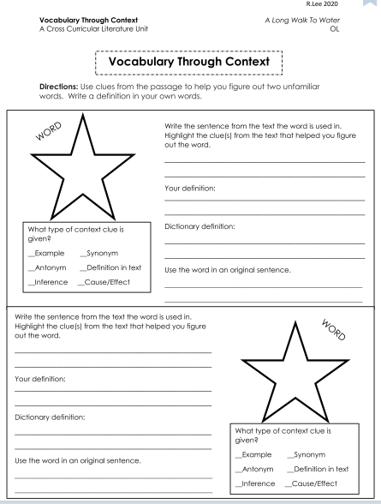

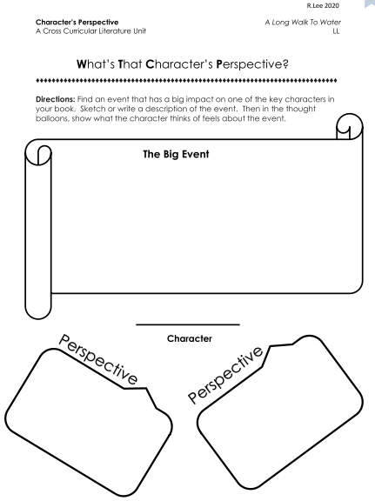

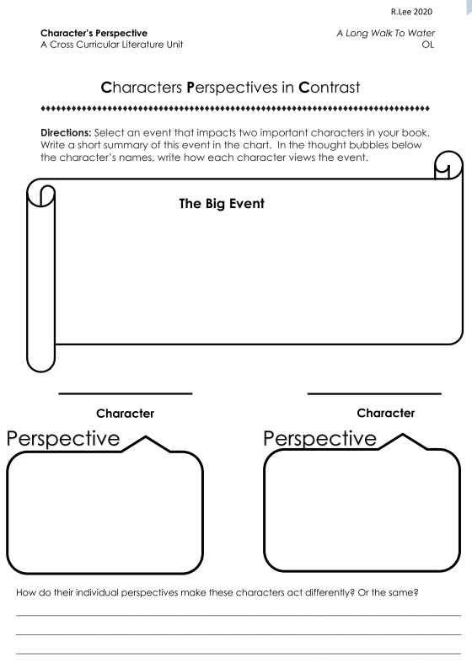

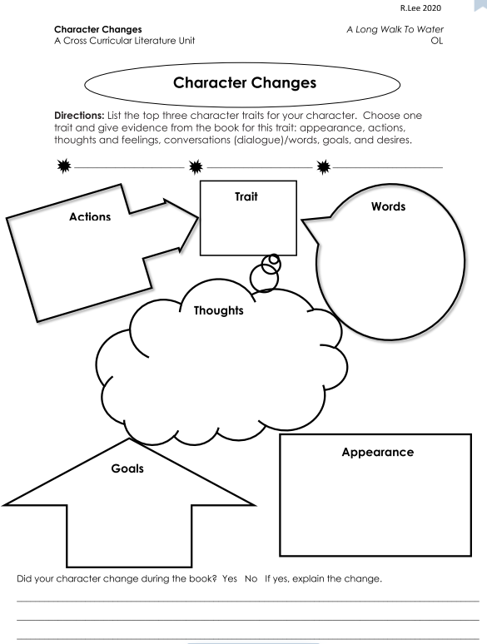

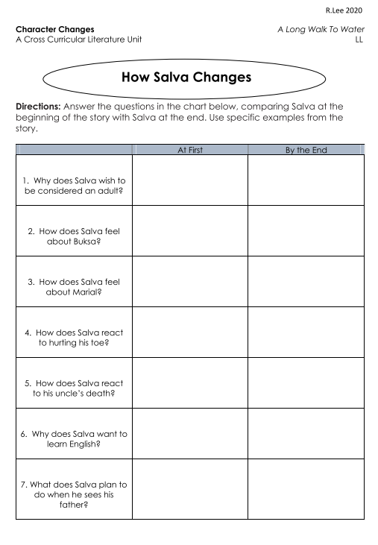

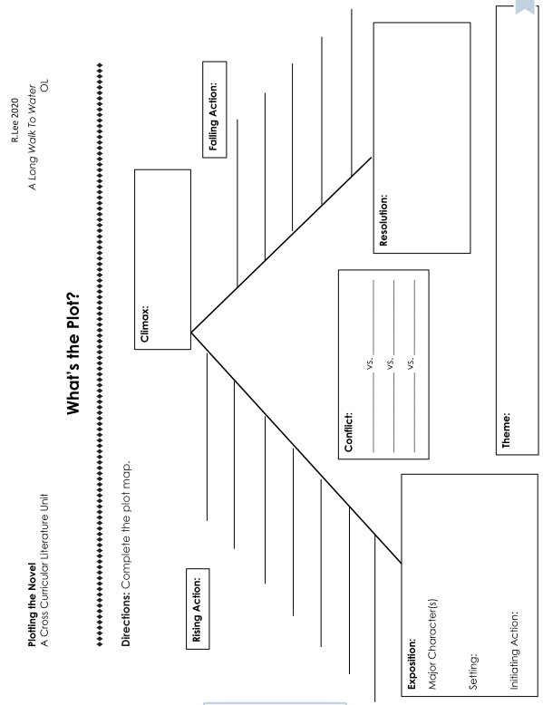

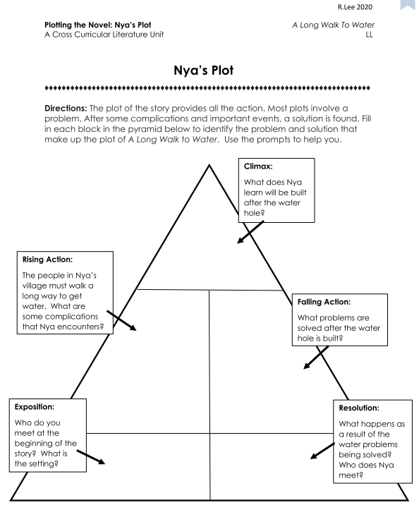

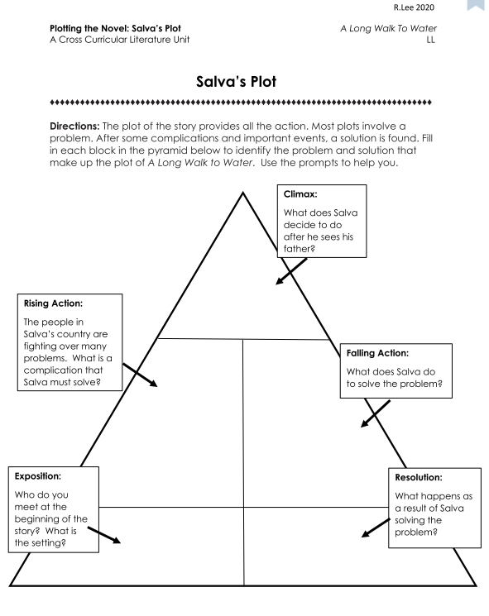

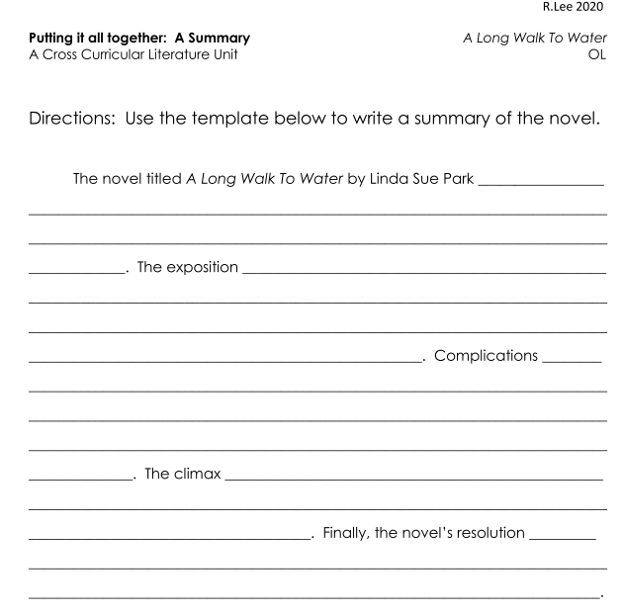

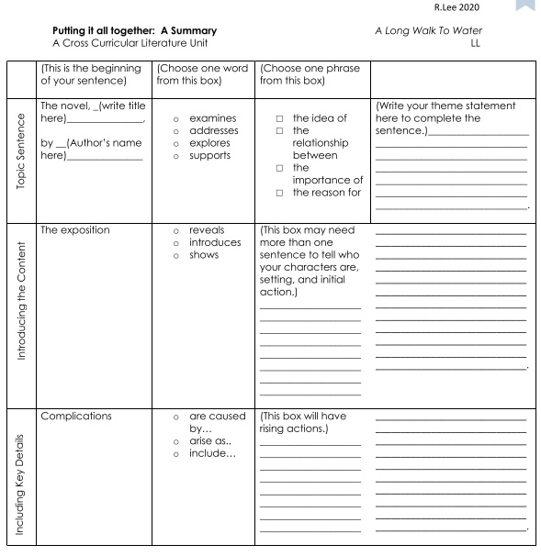

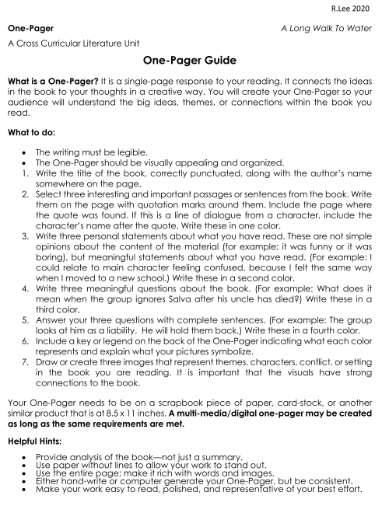

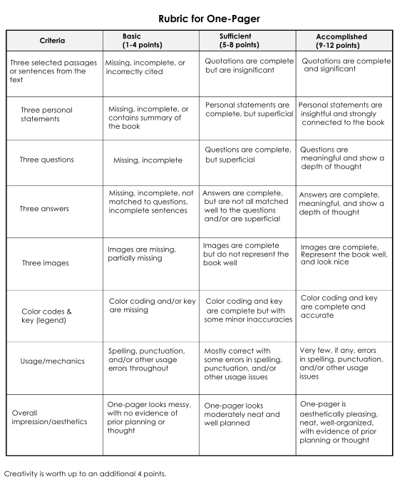

**Writing Prompts** *A Long Walk To Water* A Cross Curricular Literature Unit

**Below are some suggested SOL writing prompts that can correlate to the topics and themes within the novel.**

People often credit their successes to having good attitudes. Explain the benefits of having a good attitude, even during a difficult time. Provide examples from your own experience or from having witnessed this in others.

The ancient Greek storyteller Aesop said, “No act of kindness, no matter how small, is ever wasted.” Explain how small acts of kindness can have an impact on others. Use specific details and examples in your response.

Thoughtful acts can take many forms, such as unexpected help or even just a kind word. Explain how a thoughtful act can benefit those involved. Use specific details and examples in your response.

Sometimes people recognize similarities between themselves and a character from a book or a movie. Write about a character from a book or a movie who you think is similar to you. What do you have in common with this character? Use specific details and examples in your response.

Civil rights leader Mahatma Gandhi wrote, “Be the change you want to see in the world.” What is one way you would like to change the world, and how can you help to bring about this change? Use specific details and examples in your response.

What makes someone a success? Explain how you define success, using specific details and examples in your response.

American jazz legend Duke Ellington said, “A problem is a chance for you to do your best.” Explain the meaning of this statement and whether you agree or disagree with it. Use specific details and examples in your response.

Is it better to take risks and perhaps make some mistakes or remain cautious and risk nothing? Explain using specific details and examples in your response.

What is something you would like to accomplish in the future? Perhaps you would like to learn how to play an instrument, graduate at the top of your class, or visit the ocean. Identify one thing you would like to accomplish, and include specific details and examples to help explain why it is important.

Identify a challenge facing students, and use specific details and examples to explain ways to overcome that challenge.

Scientist Albert Einstein said, “Imagination is more important than knowledge.” Do you agree or disagree with this statement? Include specific details and examples to convince others to support your position.

People sometimes say that failure can eventually lead to success. Do you agree or disagree with this statement? Use specific examples to convince others to support your position. What improvement would make your community better? Use specific details and examples to convince the mayor of your community to accept your idea for improving where you live.

**Virginia English SOL Correlations**

**Below are some suggested tested Virginia standards that can correlate to the topics, themes, and activities within the novel and this cross curricular unit.**

**6.4 The student will read and determine the meanings of unfamiliar words and phrases within authentic texts.**

A. Identify word origins and derivations.

B. Use roots, affixes, synonyms, and antonyms to expand vocabulary.

C. Use context and sentence structure to determine meanings and differentiate among multiple meanings of words.

D. Identify and analyze the construction and impact of figurative language.

E. Use word-reference materials.

F. Extend general and cross-curricular vocabulary through speaking, listening, reading, and writing.

**6.5 The student will read and demonstrate comprehension of a variety of fictional texts, literary nonfiction, and poetry.**

A. Identify the elements of narrative structure, including setting, character, plot, conflict, and theme.

B. Describe cause-and-effect relationships and their impact on plot.

C. Explain how an author uses character development to drive conflict and resolution.

D. Differentiate between first and third person point of view.

E. Describe how word choice and imagery contribute to the meaning of a text.

F. Draw conclusions and make inferences using the text for support.

G. Identify the characteristics of a variety of genres.

H. Identify and analyze the author’s use of figurative language.

I. Compare/contrast details in literary and informational nonfiction texts.

J. Identify transitional words and phrases that signal an author’s organizational pattern.

K. Use reading strategies to monitor comprehension throughout the reading process.

**6.6 The student will read and demonstrate comprehension of a variety of nonfiction texts.**

A. Skim materials using text features such as type, headings, and graphics to predict and categorize information.

B. Identify main idea.

C. Summarize supporting details.

D. Create an objective summary including main idea and supporting details.

E. Draw conclusions and make inferences based on explicit and implied information.

F. Identify the author’s organizational pattern(s).

G. Identify transitional words and phrases that signal an author’s organizational pattern.

H. Differentiate between fact and opinion.

I. Identify cause-and-effect relationships.

J. Analyze ideas within and between selections, providing textual evidence.

K. Use reading strategies to monitor comprehension throughout the reading process.

**This SOL is not tested in grade 6 but supports the grade 8 Writing SOL.**

**6.7 The student will write in a variety of forms, to include narrative, expository, persuasive, and reflective, with an emphasis on narrative and reflective writing.**

A. Engage in writing as a recursive process.

B. Choose audience and purpose.

C. Use a variety of prewriting strategies to generate and organize ideas.

D. Organize writing to fit mode or topic.

E. Write narratives to include characters, plot, setting, and point of view.

F. Establish a central idea, incorporating evidence and maintaining an organized structure.

G. Compose a thesis statement for expository and persuasive writing.

H. Write multiparagraph compositions with elaboration and unity.

I. Use transition words and phrases.

J. Select vocabulary and information to enhance the central idea, tone, and voice.

K. Expand and embed ideas by using modifiers, standard coordination, and subordination in complete sentences.

L. Revise writing for clarity of content including specific vocabulary and information.

**7.4 The student will read and determine the meanings of unfamiliar words and phrases within authentic texts.**

A. Identify word origins and derivations.

B. Use roots, affixes, synonyms, and antonyms to expand vocabulary.

C. Identify and analyze the construction and impact of figurative language.

D. Identify connotations.

E. Use context and sentence structure to determine meanings and differentiate among multiple meanings of words.

F. Use word-reference materials to determine meanings and etymology.

G. Extend general and cross-curricular vocabulary through speaking, listening, reading, and writing.

**7.5 The student will read and demonstrate comprehension of a variety of fictional texts, literary nonfiction, poetry, and drama.**

A. Describe the elements of narrative structure including setting, character development, plot, theme, and conflict and how they influence each other.

B. Identify and explain the theme(s).

C. Identify cause-and-effect relationships and their impact on plot.

D. Differentiate between first and third person point of view.

E. Identify elements and characteristics of a variety of genres.

F. Compare and contrast various forms and genres of fictional text.

G. Describe the impact of word choice, imagery, and literary devices, including figurative language, in an author’s style.

H. Compare/contrast details in literary and informational nonfiction texts.

I. Make inferences and draw conclusions based on the text.

J. Use reading strategies to monitor comprehension throughout the reading process.

**7.6 The student will read and demonstrate comprehension of a variety of nonfiction texts.**

A. Skim materials using text features including type, headings, and graphics to predict and categorize information.

B. Identify an author’s organizational pattern using textual clues, such as transitional words and phrases.

C. Make inferences and draw logical conclusions using explicit and implied textual evidence.

D. Differentiate between fact and opinion.

E. Identify the source, viewpoint, and purpose of texts.

F. Describe how word choice and language structure convey an author’s viewpoint.

G. Identify the main idea.

H. Summarize text identifying supporting details.

I. Create an objective summary, including main idea and supporting details.

J. Identify cause-and-effect relationships.

K. Organize and synthesize information for use in written and other formats.

L. Analyze ideas within and between selections providing textual evidence.

M. Use reading strategies to monitor comprehension throughout the reading process.

**This SOL is not tested in grade 7 but supports the grade 8 Writing SOL.**

**7.7 The student will write in a variety of forms to include narrative, expository, persuasive, and reflective, with an emphasis on expository and persuasive writing.**

A. Engage in writing as a recursive process.

B. Choose intended audience and purpose.

C. Use a variety of prewriting strategies to generate and organize ideas.

D. Organize writing structure to fit form or topic.

E. Establish a central idea incorporating evidence, while maintaining an organized structure and a formal style.

F. Compose a thesis statement for persuasive writing that includes a position.

G. Clearly state a position and organize reasons and evidence, using credible sources.

H. Distinguish between fact and opinion to support a position.

I. Write multiparagraph compositions with elaboration and unity.

J. Use transition words and phrases within and between paragraphs.

K. Develop and modify the central idea, tone, and voice to fit the audience and purpose.

L. Expand and embed ideas by using modifiers, standard coordination, and subordination in complete sentences.

M. Use clauses and phrases for sentence variety.

N. Revise writing for clarity of content including specific vocabulary and information.

**8.4 The student will apply knowledge of word origins and figurative language to extend vocabulary development within authentic texts.**

A. Identify and analyze the construction and impact of an author’s use of figurative language.

B. Use context, structure, and connotations to determine meaning and differentiate among multiple meanings of words and phrases.

C. Use roots, affixes, synonyms, and antonyms to determine the meaning(s) of unfamiliar words and technical vocabulary.

D. Identify the meaning of common idioms.

E. Use word-reference materials to determine meanings and etymology.

F. Discriminate between connotative and denotative meanings and interpret the connotation.

G. Extend general and cross-curricular vocabulary through speaking, listening, reading, and writing.

**8.5 The student will read and analyze a variety of fictional texts, literary nonfiction, poetry, and drama.**

A. Analyze how authors’ development of characters, conflict, point of view, voice, and tone convey meaning.

B. Identify cause-and-effect relationships and their impact on plot.

C. Explain the development of the theme(s).

D. Explain the use of symbols and figurative language.

E. Make inferences and draw conclusions based on explicit and implied information using references to the text for support.

F. Identify and analyze characteristics within a variety of genres.

G. Compare/contrast details in literary and informational nonfiction texts.

H. Compare and contrast the authors’ use of word choice, dialogue, form, rhyme, rhythm, and voice in different texts.

I. Compare and contrast authors’ styles.

J. Use reading strategies to monitor comprehension throughout the reading process.

**8.6 The student will read, comprehend, and analyze a variety of nonfiction texts.**

A. Identify an author’s organizational pattern using textual clues, such as transitional words and phrases.

B. Apply knowledge of text features and organizational patterns to analyze selections.

C. Skim materials to develop an overview or locate information.

D. Make inferences and draw conclusions based on explicit and implied information using evidence from text as support.

E. Analyze the author’s qualifications, viewpoint, word choice, and impact.

F. Analyze details for relevance and accuracy.

G. Differentiate between fact and opinion.

H. Identify the main idea.

I. Summarize the text, identifying supporting details.

J. Identify cause-and-effect relationships.

K. Evaluate, organize, and synthesize information for use in written and other formats.

L. Analyze ideas within and between selections, providing textual evidence.

M. Use reading strategies to monitor comprehension throughout the reading process.

**8.7 The student will write in a variety of forms to include narrative, expository, persuasive, and reflective, with an emphasis on expository and persuasive writing.**

A. Engage in writing as a recursive process.

B. Choose intended audience and purpose.

C. Use prewriting strategies to generate and organize ideas.

D. Organize writing structure to fit form or topic.

E. Establish a central idea incorporating evidence, maintaining an organized structure and formal style.

F. Compose a thesis statement for persuasive writing that advocates a position.

G. Clearly state and defend a position with reasons and evidence from credible sources.

H. Identify a counterclaim and provide a counter - argument.

I. Distinguish between fact and opinion to support a position.

J. Organize information to provide elaboration and unity.

K. Develop and modify the central idea, tone, and voice to fit the audience and purpose.

L. Revise writing for clarity of content, word choice, sentence variety, and transitions among paragraphs.

Works Cited

*CommonLit*, CommonLit, 2014, [www.commonlit.org/](http://www.commonlit.org/).

Dutro, and Levy. “Constructing Meaning: Explicit Language for Content Instruction.” *ELAchieve*, 2008, www.elachieve.org/.

Witherell, Nancy L., and Mary C. McMackin. *Teaching Reading through Differentiated Instruction with Leveled Graphic Organizers*. Scholastic, 2005.

McDonald, Jan. *Teachers Guide to A Long Walk to Water.* Rocky Mountain Readers.